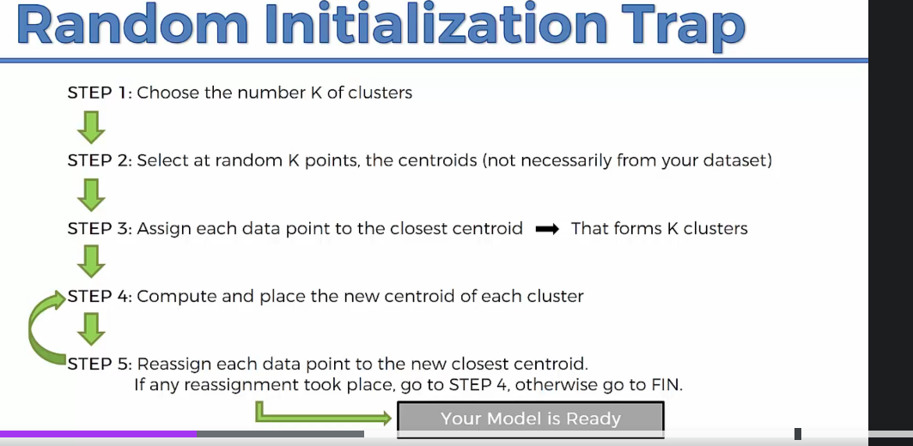

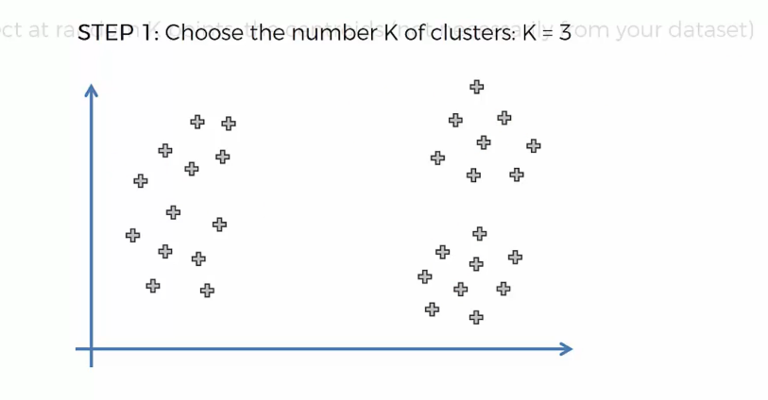

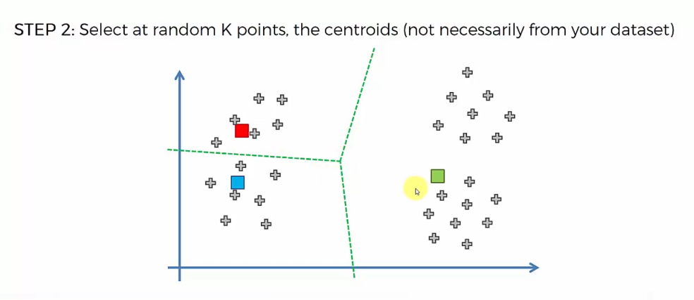

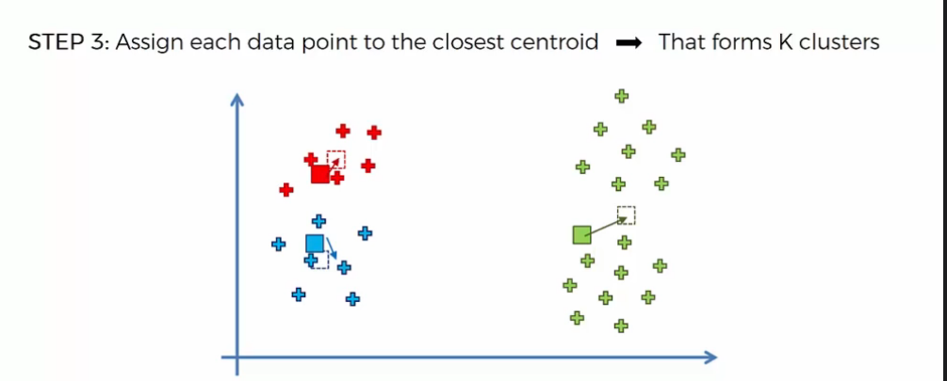

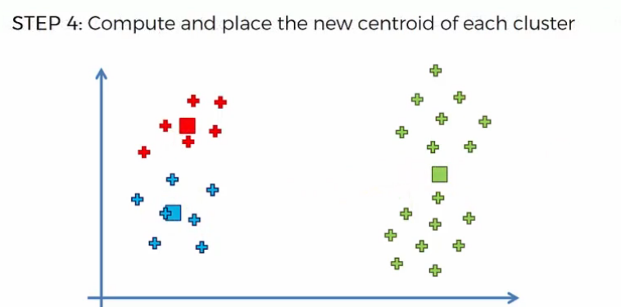

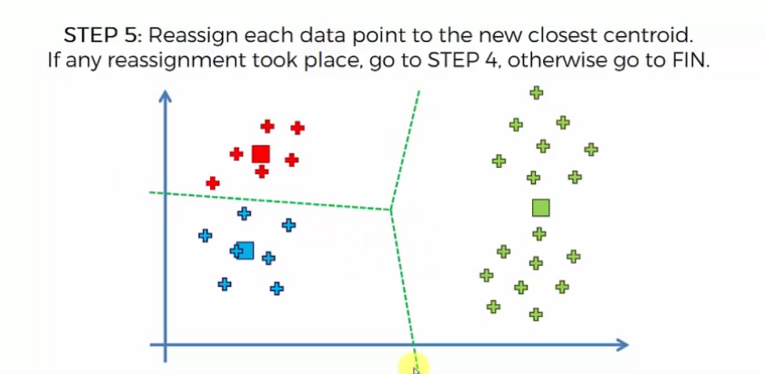

**Advantages**

• Easy to implement

• With a large number of variables, K-Means may be computaHonally faster than hierarchical clustering (if K is small).

• k-Means may produce Hghter clusters than hierarchical clustering

• An instance can change cluster (move to another cluster) when the centroids are recomputed. **Disavantages**

• Difficult to predict the number of clusters (K-Value)

• Initial seeds have a strong impact on the final results

• The order of the data has an impact on the final results

• **Sensitive to scale**: rescaling your datasets (normalizaHon or standardizaHon) will completely change results. While this itself is not bad, not realizing that you have to spend extra attention to scaling your data might be bad.